**WIRE SHARK – ARP and HTTP**

* **ARP WIRE SHARK**

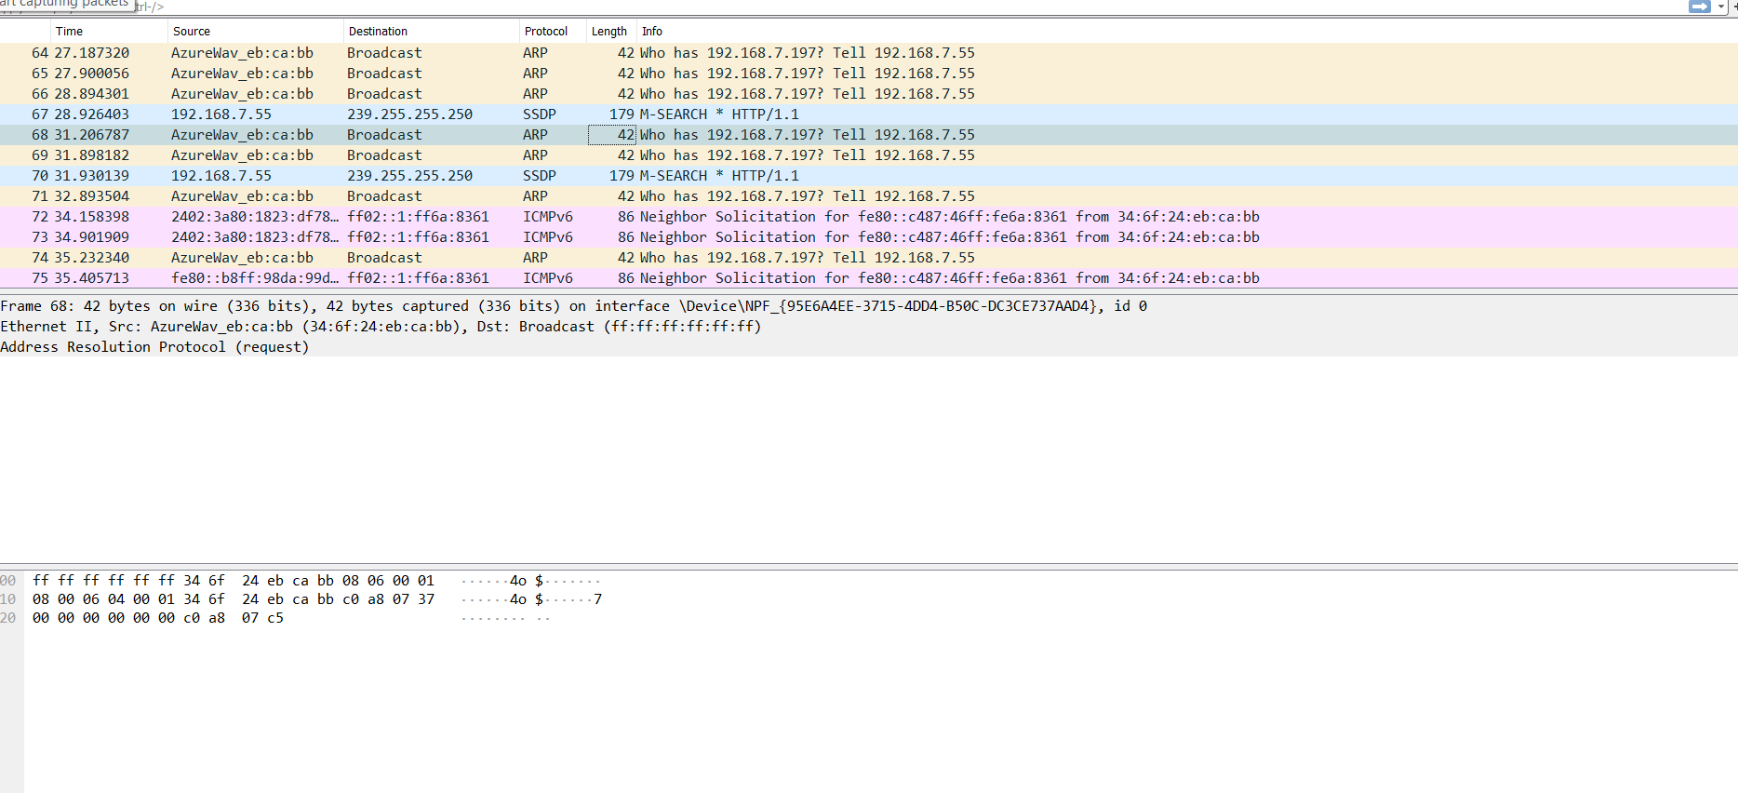

* **HTTP WIRE SHARK**

